**Disease: Viral**

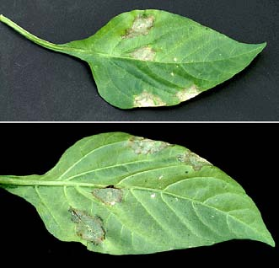Viruses are intracellular (inside cells) pathogenic particles that infect other living organisms. Human diseases caused by viruses include chickenpox, herpes, influenza, rabies, small pox and AIDS (acquired immunodeficiency syndrome). Although these are the viruses most of us are familiar with, the first virus ever described and from which the term was eventually derived was tobacco mosaic virus or TMV (the term virus was derived from the original description of the causal agent of TMV—“contagium vivum fluidum” or contagious living fluid). TMV was discovered by Martinus W.

Beijerinck, a Dutch microbiologist, in 1898.

**Treatment**

Once plants are infected, little can be done to free them from the virus.

***1. GENETIC HOST RESISTANCE***

* Since different cultivars and species show different degrees of resistance to some viruses, resistant types should be planted whenever they are available. Recent advances in plant cell molecular biology and virology have led to the development of genetically modified plants with superior resistance to some viruses.

***2. CULTURAL PRACTICES***

There are numerous cultural practices that can be used to reduce plant losses due to virus infection.

* Scouting and removal of symptomatic plants or known alternative weed or volunteer plants that may serve as a reservoir for a given virus.
* For cutting, grafting or propagating seedlings vegetatively, use cleaner or sanitized tools and equipment, and disposable overcoat; wash hands frequently.
* Rotations to non-host crops.
* Geographic isolation of production facilities may also help avoid losses caused by plant viruses.
* The isolation of newly received plant material prior to its introduction into the rest of a production system can also minimize the unintentional introduction of pathogens.